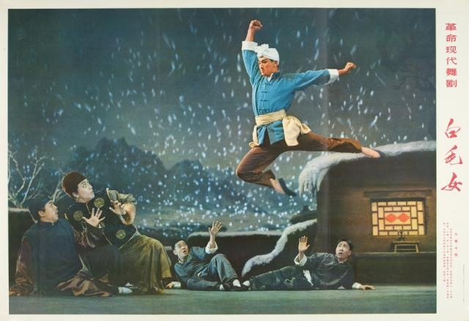
The Myth of Communist Revolution
and
Rituals of Scapegoating:
Red Literary Classics Revisited

革命记忆与暴力神话：
重读中国红色经典

Rujie Wang
The College of Wooster

“In their eagerness to deliver the country from an unprecedented crisis, modern Chinese intellectuals immersed themselves in state-building which, initially at least, seemed to offer solutions. This prevented them from attaining a crucial level of cultural reflection—not on the material or institutional changes themselves, but on the epistemological values that informed them. This lack of self-scrutiny distorted evaluations of the Chinese cultural tradition in the face of pressure to modernize and led to a moral and an analytical impasse.”

Helen F. Siu____ Furrows: Peasants, Intellectuals, and the State

Abstract
A revisit of such red classics as the novel "Sun Shone over Sanggan River" (Ding Ling, 1947), "Hurricane" (Zhou Libo, 1947), libretto and ballet "White Haired Girl" (He Jingzhi, 1947), novel "Ku cai hua" (Feng Deying,1957), "Keep the Red Flag Flying" (Liang Bin, 1957), film and ballet "The Red Detachment of Women" (1961), "Bright Sunny Day" and "The Golden Road" (Hao Ran, 1964, 1972) reveals what Rene Girard refers to as “victimage mechanism,” which makes them “persecution texts” of one kind or another. Central to these red classics produced to proselytize Mao's idea of communism is the fanshen myth operating in ways that satisfy the needs of the collective unconscious to revenge on the powerful by the formerly powerless.

The libretto and film White Haired Girl and the ballet and film Red Detachment of Women typify the triumph of the will to destroy human worldly power and to rule by the tyranny of the weak. As a modern nation, the PRC was founded on what D.H. Lawrence refers to as “the religion of the self-glorification of the weak, the reign of the pseudo-humble.” These works of art make Mao into a god of the weak and justify violence against scapegoating victims of sacrificial crisis. As the memories of the communist revolution continue and become elaborated in art, the extermination of the landlords as a class became forgotten. It is apparent that “in the final stages of the evolution of myths the founding murder itself is often lost from view” because, as Rene Girard points out, “to accept responsibility for scapegoating would be to acknowledge the arbitrary, violent origins of cultural institutions and society itself.”

Even before 1949 when the communists took control of Mainland China, the idea had been very popular (since 1919 May Fourth movement) to use art and literature as a vehicle for state building, responsible for the production of a canonical body of texts, known as the red classics. These works show, among other things, how literary intelligentsia understood such Western concepts as freedom and democracy, by recording the history of modern China as it was being made, and by remembering the past before things came to pass. Such political fiction is almost by definition propaganda that lends itself to analysis of myth that, as Roland Barthes understands it, “[myth] is a type of speech. … Myth is not defined by the object of its message, but by the way in which it utters this message.” The revolutionary literature is written for people yet to become the intended reader, and about social events still too volatile to be conceptualized. This situation where you can eat your cake and have it too attests to the view of George Sorel that, in his Reflections on Violence, “myth must be judged as a means of acting on the present; any attempt to discuss how far it can be taken literally as future history is devoid of sense.” In his Yan’an Talk on art and literature in 1942, Mao Zedong makes it clear that the literary intelligentsia should serve the masses (the “workers,” “peasants,” and “soldiers”), and that revolutionary literature is a matter of having the right worldview and attitude towards a new China soon to emerge in the shape that the revolutionaries would envision it.

To Mao and revolutionary writers, what was important to remember was the communist version of social justice. In his famous Yan’an Talk, we see that social justice through the lens of Mao as a revolutionary already reinventing himself as one of the heroes of his own myth and fiction.

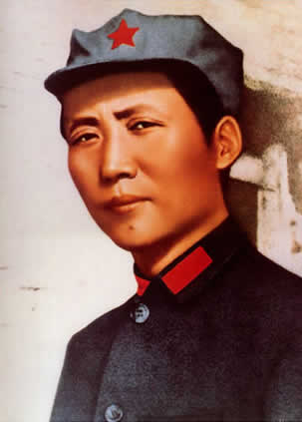
Here I might mention the experience of how my own feelings changed. I began life as a student and at school acquired the ways of a student; I then used to feel it undignified to do even a little manual labor, such as carrying my own luggage in the presence of my fellow students, who were incapable of carrying anything, either on their shoulders or in their hands. At that time I felt that intellectuals were the only clean people in the world, while in comparison workers and peasants were dirty. I did not mind wearing the clothes of other intellectuals, believing them clean, but I would not put on clothes belonging to a worker or peasant, believing them dirty. But after I became a revolutionary and lived with workers and peasants and with soldiers of the revolutionary army, I gradually came to know them well, and they gradually came to know me well too. It was then, and only then, that I fundamentally changed the bourgeois and petty-bourgeois feelings implanted in me in the bourgeois schools. I came to feel that compared with the workers and peasants the un-remolded intellectuals were not clean and that, in the last analysis, the workers and peasants were the cleanest people and, even though their hands were soiled and their feet smeared with cow-dung, they were really cleaner than the bourgeois and petty-bourgeois intellectuals. That is what is meant by a change in feelings, a change from one class to another. If our writers and artists who come from the intelligentsia want their works to be well received by the masses, they must change and remold their thinking and their feelings.

This personal transformation came with it a change in perspectives, values and attitudes. The change makes possible a new sense of social justice whereby kindness and compassion for the poor and downtrodden, dirty and uneducated that they were, meant brutal and cruel treatment for rich and powerful, clean and learned as they were. This highly prejudicial and biased view of the revolution guided Mao and many revolutionary writers in their political analysis of China, especially their understanding of the rural reform to empower the land-less and land-poor against the landlord class as well as the intellectuals. Central to the political ideology of Mao is this sense of social justice that is at once humanizing and brutal, which is why as a revolutionary leader, Mao makes no effort to sugarcoat his view on the violent overthrow of the old social system, essential to the aesthetic of the red classics.

There is absolutely no such thing in the world as love or hatred without reason or cause. As for the so-called love of humanity, there has been no such all-inclusive love since humanity was divided into classes. All the ruling classes of the past were fond of advocating it, and so were many so-called sages and wise men, but nobody has ever really practiced it, because it is impossible in class society. There will be genuine love of humanity -- after classes are eliminated all over the world. Classes have split society into many antagonistic groupings; there will be love of all humanity when classes are eliminated, but not now. We cannot love enemies, we cannot love social evils; our aim is to destroy them.

As is apparent in Mao’s talk to the literary intelligentsia, what revolutionary writers and artists must make clear in their works is the necessity for collective violence against the evils of the landlord class through land reform, and against the nationalists in the civil war who represent the interests of the national bourgeoisie. Inherent in the myth of the communist revolution is the ritual or mechanism of scapegoating soon to be elaborated in the literary works of red classics that show a variety of stereotypes of persecution against those perceived as the public enemies.

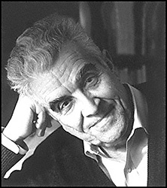
According to Rene Girard, violence often results when mimetic desire and rivalry creates a sacrificial crisis or eclipse of culture in which there is a temporary loss of cultural distinctions and differences on which people rely while interacting with one another. To stop chaos as well as restore peace and unity, people often resort to rituals through which to sacrifice a few “scapegoat or surrogate victims” whose removal would end the crisis, which is why it is a “sacrificial crisis.” Girard’s theories of mimetic rivalry, victimage mechanism, and sacrificial crisis provide frameworks for understanding the founding of the People’s Republic which, brutal and violent as it was, brought law and order. They also give us perspectives and insights into the red literary classics that, perhaps even more than the official history, help us remember the communist revolution in which the landlords fell victims of sacrificial violence the same way as the Jews, the witches, or the gulags. In these collective persecutions, “the cycles of violence go on to usher in a new stable social condition,” and through which “the community must effectively be emptied of its poisons. It must feel liberated and reconciled within itself.” The function of all red classics is that of the “persecution text,” providing a scenario of ‘good’ violence that is satisfactory and gratifying to the ritualistic mind. In other words, in a moment of national crisis such as the Japanese military occupation of China or the civil war in the late 1940s, people tended to follow the rituals through which order is restored or established, such as the rituals in which a group or class of people is identified and sacrificed as scapegoat victims, rituals found in “medieval records of anti-Semitic violence, of the Inquisition, and of witch trials. In these texts Jews or others are blamed for the ills besetting the community. They are charged with the most heinous of crimes which supposedly justify their persecution.” In the red classics that dramatize Mao’s vision of the communist revolution, collective violence against the landed gentry is viewed as just because such violence is believed to bring the unity of the community rather than violent reciprocity. And this is why “in the final stages of the evolution of myths the founding murder itself is often lost from view” because “to accept responsibility for scapegoating would be to acknowledge the arbitrary, violent origins of cultural institutions and society itself.”

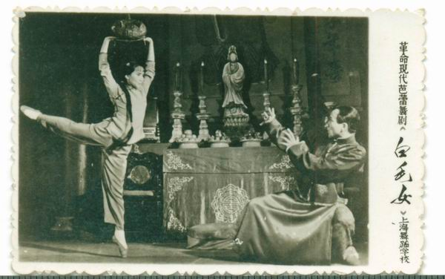
Nowhere is Mao’s redefinition of humanity and social justice through the dictatorship of the proletariat given fuller expression or finer artistic elaboration than in the libretto White Haired Girl (1947), which won the Stalin Peace Prize for Literature and Art in 1951. In this “persecution text,” landlord Huang Shi-ren is singled out and executed as an e ba (despot) who collaborates with the Japanese and brutalizes the powerless. In the words of the dramatist, the message is that: “The old society changed people into ghosts, while the new society changes ghosts into people.” The heroine of the story is Xi’er, a peasant woman forced to work in Huang’s estate because her father, Yang Bai-lao, is unable to pay debts owed to Huang. Sad at the loss of his daughter, Yang commits suicide, followed by Xi’er’s rape by Huang. Pregnant and grieved over her father’s death, Xi’er runs away and hides in the mountains for three years until her hair turns white, which scares people who see her. When her lover Da Chun returns to the village a revolutionary he and Xi’er become reunited and, along with other villagers, take out Huang to avenge the dead and wronged. As a red classic, the libretto, and later the film and ballet, epitomizes a larger scale political effort to scapegoat and wipe out the landlord class in the estimated numbers from 800,000 to 2 millions.

This “fanshen” drama shows the violent origins of the communist culture, and the acts of foundational, sacrificial violence, viewed from the standpoint of the prosecutor. The historical meaning of this revolutionary drama is offering an enactment or elaboration of the scapegoat ritual or collective violence to get rid of evil during the time of cultural eclipse. “The rite [of sacrificial violence] selects certain form of violence as ‘good’, as necessary to the unity of the community, and sets up in opposition to it another sort of violence that is deemed ‘bad’, because it is affiliated to violent reciprocity.” The logic of fanshen is also the rationale for land reform central to the communist struggle to defeat the Japanese invaders and to win victory in the ensuing civil war against the nationalists. The violence against landlord Huang who represents the landlord class could be and has been rationalized as “good violence” in that it is warranted by the needs to abolish “the agrarian system of feudal and semi-feudal exploitation,” and landownership rights of all landlords,” and to cancel “all debts incurred in the countryside prior to the reform of agrarian system.” That is why at the end of both the libretto and ballet when landlord Huang is executed, the villagers cheer and shout “fanshen,” representing the emancipation and national solidarity of hundreds of millions of landless and land-poor peasants to be mobilized in the communist struggle for a new social system. The stereotypes of persecution or victimary mechanism remain unrecognized as people emphasize the need for fanshen, comparing it as William Hinton did in his book entitled Fanshen, to the American Civil War and the emancipation of the slaves.

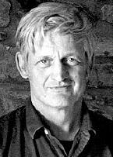
Every revolution creates new words. The Chinese Revolution created a whole new vocabulary. A most important word in this vocabulary was fanshen. Literally, it means ‘to turn the body,’ or ‘to turn over.’ To China’s hundreds of millions of landless and land-poor peasants it meant to stand up, to throw off the landlord yoke, to gain land, stock, implements, and houses. But it meant much more than this. It meant to throw off superstition and study science, to abolish ‘word blindness’ and learn to read, to cease considering women as chattels and establish equality between the sexes, to do away with appointed village magistrates and replace them with elected councils. It meant to enter a new world.

This rational explanation for brutal struggle against the landed gentry is exactly how He Jingzhi, Ding Yi, and Ma Ke of the Yan’an Lu Yi Team of Art Production understood the land reform when they produced this propaganda drama that has outlasted the political campaign itself. The libretto fully justifies the collective violence against the landlord class as it emancipated millions of landless and land-poor peasants such as Xi’er and Da Chun. The libretto educates the peasants about the need for communist revolution as a way to achieve freedom and democracy by staging the prosecution of an evil landlord. Essentially, the libretto showcases what violence is good violence, an issue on which Hinton borrowed the eloquence of Mark Twain by quoting him speaking on the “Reign of Terror” during the French Revolution when many aristocrats were put to death by the guillotine to honor the principles of liberty, benevolence and equality.

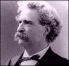
There were two ‘Reigns of Terror’ if we should but remember it and consider it; the one wrought murder in hot passion, the other in heartless cold blood; the one lasted mere months, the other lasted a thousand years; the one inflicted death upon a thousand persons, the other upon a hundred millions; but our shudders are all for the ‘horrors’ of the minor terror, the momentary terror, so to speak; whereas, what is the horror of swift death by the axe compared with lifelong death from hunger, cold insult, cruelty, and heartbreak? What is swift death by lightning compared with slow death by fire at stake? A city cemetery could contain the coffins filled by the brief Terror which we have all been so diligently taught to shiver and mourn over, but all France could hardly contain the coffins filled by the cold and real Terror—that unspeakable bitter and awful Terror which none of us has been taught to see in its vastness or pity as it deserves.

Twain’s words express, among other things, compassion for the poor and humble as well as justification for their violent struggle to over throw the powerful through the ritual of scapegoating that minimizes violence. This is basically why White Haired Girl was and is popular with people hoping freedom and equality for the downtrodden and powerless, similar to the way Mark Twain understood the collective violence against the French aristocrats. By staging “that unspeakable bitter and awful Terror which none of us has been taught to see in its vastness,” the libretto makes a powerful case against the e ba landlord and scapegoats them as a class.

However, beyond this rational and moral approach to art and politics, there are also ways of looking at human events, real or dramatized, on a more fundamental level. For example, if we look at this piece of red classics from the perspective of myth and ritual, especially the rituals of scapegoating or stereotypes of persecution, then we would see not just reasons for violent revolution, which are perfectly defendable on rational level, but also human propensities responsible for what we do more than reasons, and binding us together as a species with mimetic desire and aggression that reasons cannot defend. If we look carefully at the external trappings of this red classic, then we find the same basic ingredients of a sacrificial crisis. In landlord Huang we see the presence of the monstrous, which is what polarizes the crowd against him as a scapegoat. He collaborates with the Japanese invaders and commits treason against his own people during a cultural eclipse in which society becomes less differentiated. His moral monstrosity supports and justifies the violent acts taken against him.

With feasting and wine we see the Old Year out,
And hang lanterns and garlands to celebrate New Year’s eve!
There are smiles on the faces of all our guests
Who are drunk with joy, not wine.
Our barns are bursting with grain,
So who cares if the poor go hungry!

His total disregard for the poor and his ruthlessness mark him a perfect villain. Besides his wealth and privilege in the village, his debauchery is another victimary sign that marks him as a scapegoat: “Well, I haven’t lived in vain! I’ve nearly a hundred hectares of good land, and every year I collect at least a thousand piculs in rent. All my life I have known how to weigh the scales in my own favor and manage things smoothly both at home and outside. During the last few years our family has done well. Last year my wife died. My mother wants me to remarry but I feel freer without a wife at home. Women are cheap as dirt. If one takes my fancy, like this one tonight, it’s very easy to arrange.” His attitudes as one of the rich and powerful who, in normal times, “enjoy all sorts of protection and privileges which the disinherited lack” but who, during periods of crisis, often find “that the odds of a violent death at the hands of a frenzied crowd are statistically greater for the privileged than for any other category,” because “crowds commonly turn on those who originally held exceptional power over them.” Landlord Huang’s lust for and subsequent rape of Xi’er activates the mechanism of his own persecution as a scapegoat in an eclipse of culture about which he knows nothing. In this fanshen story, the guilty is punished as they always are by death or banishment, which happens in the story of Oedipus as a persecution text.

The plague is ravaging Thebes: here we have the first stereotype of persecution. Oedipus is responsible because he has killed his father and married his mother: here is the second stereotype. The oracle declares that, in order to end the epidemic, the abominable criminal must be banished. The finality of persecution is explicit. Parricide and incest serve openly as the intermediaries between the individual and the collective.

To illustrate how Sophocles’ account of the myth would work as an all-against-one persecution that can easily happen in any place and time, Girard offers his own rendition of the Oedipus story. This generic and skeletal form of the Greek tragedy gives us a keener awareness of the revolutionary libretto The White Haired Girl, as well as multiple red classics, as persecution text written to scapgoat any and every one standing in the way of China’s war against Japanese aggression and communist struggle to achieve power.

Harvests are bad, the cows give birth to dead calves; no one is in good terms with anyone else. It is as if a spell had been cast on the village. Clearly, it is the cripple who is the cause. He arrived one fine morning, no one knew from where, and made himself at home. He even took the liberty of marrying the most obvious heiress in the village and had two children by her. All sorts of things seemed to take place in their house. The stranger was suspected of having killed his wife’s former husband, a sort of local potentate, who disappeared under mysterious circumstances and was rather too quickly replaced by the newcomer. One day the fellows in the village had had enough; they took their pitchforks and forced the disturbing character to clear out.

Here, too, a number of things about Landlord Huang that augur badly for his future, among which these are the most damning: he coerces Yang Bailao to trade in his daughter for the debt he owes, which results in Yang’s suicide and incurs the wrath of the villagers. He impregnates Xi’er but refuses to marry her, which outrages her and makes it impossible to forgive his cruelty against her father. His intent to sell Xi’er instead of marrying her compels her to run into exile in the wild while pregnant. Because he violates Xi’er, he also antagonizes Wang Dachun in love with her. These actions more than cancel out his identity as an ordinary villager afraid of the Japanese just like everyone else; “It’s appalling. The Japanese kill people and set fire to houses! All my in-laws have fallen into their hands.”

Actually it is pointless or at least unimportant to compare the concrete details of the revolutionary drama with those in the Oedipus myth because, “In the case of a text written by the persecutors the only elements of it that should be believed are those that correspond (1) to the real circumstances of the texts coming into being, (2) to the characteristic traits of its usual victims, and (3) to the results that normally follow collective violence.” What gave rise to the persecution and elimination of Landlord Huang are circumstances of social crisis or eclipse of culture. His trial is characteristic of collective violence against the scapegoat victim because Huang does not represent a historical individual or even a social group but rather a monster and the Evil itself. And as usually happens in all cases of sacrificial violence, the elimination of Huang is followed by the restoration of cultural order and solidarity of the community.

I want vengeance for all that happened,
My wrongs are too many to tell!
They’re a mountain that can’t be leveled,
A sea that can’t be drained!
But what’s caused such a great change
That I can beard my enemy today?
Landlord Huang—
To be cut into pieces is too good for you!
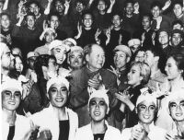
But as is characteristic of all sacrificial violence, the removal of the scapegoat victim must resemble law and order in the name of which the collective violence against the victim is seen as justified. What distinguishes the libretto, as well as most of the red classics, is its difference from other stories and texts of personal revenge. In other words, the victimary mechanism evidenced in all red classics must produce peace and unity and not reciprocate more violence. At the end of the libretto, the vengeful Da Chun and Xi’er have Huang Shiren where they want him, in front of an angry mob ready to tear him to pieces, but they agree to hand him to the CCP authority embodied by Uncle Zhao who says, “Friends! I represent the government. I support your charges against landlord Huang. We will certainly avenge Xi’er. First let us arrest Huang and Mu for public trial according to proper legal procedure.” This dramatic detail is of great importance because it introduces a higher authority to intervene and settle personal grievances, the same way Orestes, the son of Agamemnon, after murdering his mother Clytemnestra to avenge his father murdered by her, asked Apollo to be by his side and pleaded to Athena and in so doing ended the curse of the House of Atreus. The execution of Huang Shi-ren is followed by a sunrise, an iconographical and iconological allusion to Mao as the divine intervener (“Vengeance is mine”) in whose name the violence is carried out to end all violence and to guarantee eternal peace. This is the key to and politics of the collective memory of the communist revolution as recorded in the red classics. It is not that the authors and audiences are oblivious to the violence and brutality greatly elaborated, but that it is the kind of ritualized violence people associate with cultural order. As Huang Shi-ren is executed, the triumphant crowd cheers singing:

Age-old injustice must be avenged,
And a thousand years’ wrongs be set right!
Xi’er, forced to become a ghost,
Becomes human again today!
Crushing rents must be reduced,
The grain extorted must be restored!
Those who suffered their whole lives long
Will stand up (fanshen) and become the masters today!

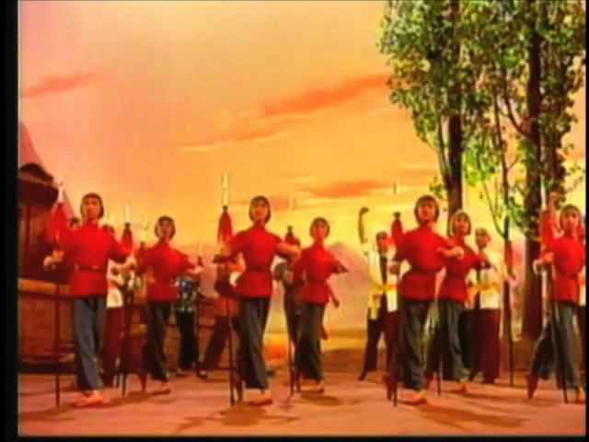

With Mao as the new ruler and the despot eliminated, the eclipse of culture is over. This is how the libretto functions as both myth and religion in that “political ideologies are the counterparts of religious belief systems—with which they coexist in varying degrees of dependence, collaboration, or rivalry in modern societies.” The staged conflict or class antagonism between the landlord and tenants, between the creditor and debtor, which is never clear in real life, offers an explanation of the deplorable social reality. The solution is the expropriation of the rich and the drastic action to divide existing wealth, which does not fundamentally “prevent the old process of differentiation which had originally produced landlord and tenants from producing them all over again.” On the stage it is easy to differentiate landlords from other groups such as rich peasants, land-poor, and landless peasants, because the audience is ideologically predisposed and conditioned to understand the ritual of scapegoating in whichever way it is elaborated in the red classics.

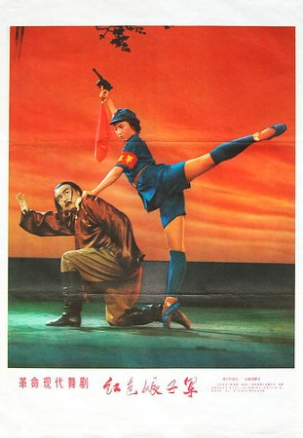
The same stereotypes of persecution and uses of scapegoat ritual are found in many classics of revolutionary literature written to make intelligible political events in which collective violence is glorified. Among these is the film The Red Detachment of Women, dir. Xie Jin, 1958, and later adapted into an opera, one of the eight model dramas during the Cultural Revolution, and a ballet performed in front of U.S. President Nixon when he visited China in 1972. Based on the true story of the all-female Special Company of the 2nd Independent Division of the Chinese Red Army first formed in 1931, this fanshen story presents the viewer with a crisis on the Hainan Island where a regional war is being fought between the communist Red Army fighting to liberate the oppressed and the nationalist troops with the support of the local warlords. In this well-known red classic, the female protagonist, Wu Qionghua, joins the Red Army, initially for her personal vendetta against the despotic landlord Nan Batian, caught in between but willing to collaborate with the nationalists when threatened by the peasants. However, with the help of Hong Changqing, her political instructor who helps her join the Red Army in the first place, Wu soon realizes that the real end to her misery and suffering does not come when she kills Nan, which she later does, but when the entire class of landlords is overthrown through communist revolution. To die at the hand of his maid and slave, Nan Batian is also a perfect scapegoat victim in this persecution text just like Huang Shiren, whose elimination signifies the emancipation of many downtrodden and oppressed men and women. Corrupt and cruel, Landlord Nan Batian is presented and seen as a tyrant that must be overthrown.

But the stereotype of persecution, if this is indeed a persecution text written from the perspective of the prosecutor, is different from White Haired Girl, where the execution of landlord Huang restores peace and unity in the community and signifies the attainment of social justice. In Red Detachment of Women, however, the execution of Nan does not enable Wu Qionghua to feel liberated or the people of Coconut Grove to feel reconciled with themselves as a community. In other words, the satisfaction of having justice done is deferred to a future time at which, after a long and arduous struggle, all Wu Qionghuas and Xi’ers are liberated from the shackles and bondages of slavery. This is effected when, after Nan escapes, Wu volunteers herself to go in disguise and bring his head back, only to be told by Hong that that is not the social justice that they as communists and Red Army fighters are risking their lives to achieve. To broaden her horizon, Hong asks Wu to find on a map of China Coconut Grove; when she realizes that it is not even represented on the map, Hong tells her that personal courage is not enough to liberate the whole country. Here we have a case where the myth of communism and the ritual of scapegoating work hand in hand to produce a version of social justice that transcends personal grievances. Wu is seen as blinded by her vendetta and told to be more conscious of the suffering of millions of others. It is only by overcoming her person hatred does she become a conscientious revolutionary and red army fighter. In White Haired Girl, the selection or choice of victims is according to the magnitude of the alleged crimes committed, and the punishment is administered in relation to the malice of the accused and guilty. In Red Detachment of Women, the effort to scapegoat Nan belongs to a much larger and more general armed struggle against a class that is particularly susceptible to persecution; namely, the rich and landed gentry all across China. The stereotype of persecution is also different in that now the victimary mechanism of the crowd banding together against a single victim has become, through political elaboration, a war to destroy and eliminate, as Mao said in his Yan’an Talk, an evil class of people. As the story ends, Wu takes over the commanding post of Hong, burned to death by Nan’s men, and says to her detachment: “Pick up your guns and beat down the enemy no matter he is Nan Batian or Bei Batian. It is not enough for us to do so. Our children need to fight following us. We’ll fight till the entire proletariat class is liberated!” Her speech is followed by the theme song that goes like this: “March forward, march forward. Soldiers’ duties are heavy as women’s grievances are strong.” Thus the film, opera, and ballet of this red classic bring to a new height the collective violence and murder, fully justified on moral, religious and political grounds.

That Wu and her red detachment of women keep on fighting a war on behalf of all women who have suffered and with grievances, after Nan Batian is eliminated, would more than answer the question about collective murder, which Adolphe Jensen phrases in this way,

What could have persuaded men to kill their fellow-beings—not in the wanton, amoral manner of barbarians succumbing to their instincts, but as a reflex of the awakened consciousness of the creator of cultural forms, seeking to comprehend the innermost nature of the world and to transmit this knowledge to future generations by means of dramatic representations?

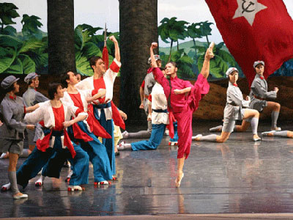
It is now a collective fight for a principle of abstract justice. Here we have a stereotype of persecution that is not the previous one where the crowd is mobilized against one scapegoat victim. If violence is not to be denied, it can be diverted to something or someone else such as a holy war because, as Girard points out in his Violence and the Sacred, “men dispose their violence more effectively if they regard the process not as something emanating from within themselves, but as a necessity imposed from without, a divine decree whose least infraction calls down terrible punishment.” As is already evident in White Haired Girl and many red classics, individual grievances are often addressed in the context of fanshen, a collective struggle led by none other than Mao, the god of the poor and downtrodden. Even though in both plays, the scapegoats are eliminated directly by the wronged party that suffer much human indignities, the vengeance is done however in the name of fanshen struggle that carries with it a principle of abstract justice as articulated ideologically through a larger political myth of communism, which is why I view them as persecution text against both the actual landlords guilty of the crimes for which they are put to death and the class of the landed gentry indicted and found guilty in theory. As Wu goes off with the Red Army, she is to fight a much greater battle against enemies whose removal would bring about the final peace and unity in China as a whole. In this respect, The Red Detachment of Women is a more important work than White Haired Girl because it elaborates the ritual of scapegoating in ways that best explain the communist revolution as the final version of social justice for not just a few individuals but for China as a whole. Little surprise that, in 1963, on the recommendation of Primer Zhou En-lai, the film “The Red Detachment of Women” was made into a ballet, and performed by National Ballet Troupe on 1964. At the end of the show, Mao Zedong said to the ballerinas that “the [theatrical] evolution is a success; the art is great, and the direction [of the remake] is correct.”

The 1960s was a time when Mao’s vision of socialism was implemented in a regimented fashion and institutionalized in such collectivization efforts as the people’s communes. In the heydays of Maoism and under the dictatorship of the proletariat, people read nothing but the works of revolutionary literature that codify the socialist ideals and values as Mao understood them. Practically the official discourse on history, these red classics effectively eliminate any opposition to Mao by elaborating on situations of class struggle in which those dissenting to and resisting Mao and the central government are depicted as saboteurs of the country that need to be removed or eliminated. In other words, Mao’s “uninterrupted revolution” theory as understood and elaborated by the literary intelligentsia creates and perpetuates endless situations of sacrificial crisis in which the dialectic of Marxism continuously produces thesis, antithesis and synthesis. The rituals of scapegoating are still central to red classics such as Bright Sunny Sky (1966), a novel written by Ran Hao and adapted into a film (1973), in which those opposed to the political campaign to collectivize agricultural sector in the 1950s are singled out or eliminated by way of scapegoat mechanism. Although quite formulaic in its structure and plot, the film really perfects the art of political persecution by showing the viewer the victimary signs of those selected as the enemies of the state. Unsurprisingly, those that fall victims to the collective violence in this political campaign are people doing well on their own, like the middle class peasants Wanwan Rao, Big Canon Ma, businessmen Fan Zhanshan, Number Five the cripple, the corrupted accountant Ma Liben, the son of a rich peasant, the ex-landlord Pigtail Ma, and Ma Zhiyue, a counter-revolutionary that managed to join the CCP and serve as the head of Dongshan Wu Village.

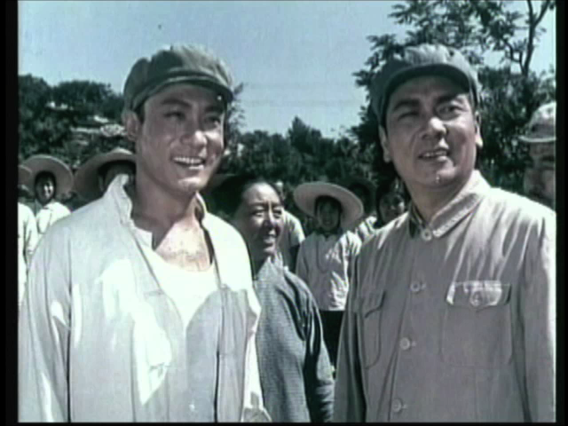

By singling out Ma Zhiyue and Pigtail Ma as saboteurs of the collective commune, the people feel united again and the community is free of poison and impurity as the bright sun (Mao) shines over the village. In other words, the purity and harmony of the community are always kept by repeated use of the scapegoat ritual and the practice of collective violence.

To put the current discussion of red classics and scapegoat rituals into proper perspective of literary history, let me conclude by mentioning the names of two literary works in which the author consciously represents revolution in terms of scapegoat victimization. Lu Xun’s The True Story of Ah Q (1921) restages the 1911 Revolution in which China became a republic. Critical of the Revolution, the author shows nothing less than the situation of cultural eclipse in which villagers scapegoat Ah Q to restore peace and unity. He is executed for the crimes of which he is not guilty when in fact he is merely imitating others whom he thinks are successful, driven by mimetic desire. He is conveniently made a scapegoat when there is a collapse of social hierarchy and the loss of difference in his village. The other literary work that elaborates on the stereotypes of persecution and the mechanisms of scapegoating is Gu Hua’s Hibiscus Town (1986) through which the author offers a critical reflection and analysis of the Cultural Revolution. The story reveals that behind the political masks people wear during the revolution are instincts of aggression to scapegoat or sacrifice those around them as a way of self-preservation. Unlike the red classics I discuss, these two texts are written from the perspective of the scapegoat victim, deepening our understanding of the way in which we use collective violence in the name of culture and society, driven and predisposed by our ritualistic mind.

The other side of the same story is what happens to the good guys, the revolutionaries such as Da Chun, Xi’er, Wu Qionghua, Hong Changqing, Gao Daquan and Xiao Changchun, and Liu Hulan and Jiang Jie. To the extent that our mimetic desire is reaffirmed when villains are scapegoated and eliminated in the red classics, it is also reinforced when the revolutionaries suffer and, in so doing, become what Girard calls the model who defines for us what it is that we desire. The removal of the villains tells only half of the story in which we scapegoat those we perceive to be in the way. The suffering endured by the revolutionary hero on our behalf readies us for the pain to come; these works of revolutionary art and literature are not really meant for the so-called “workers, peasants, and soldiers” who need food, land, or means of production; their purpose is to teach the educated what and how to want. In all red classics, the leading characters represent success to be emulated and replicated. As revolutionaries and masters of new China, each of these fictional heroes occupies the privileged position of divine power and authority. They have nothing and everything; they are the arbiters of social justice. Liu Hulan (刘胡兰), Jiang Jie（江姐）, Hong Changqing （洪常青）and Wu Qionghua (吴琼花), and Xiao Changchun （肖长春） are China’s new leaders and able to see a larger picture by denying or putting on hold their immediate needs for personal revenge and/or prosperity. They are the actors and players of theatrical sadomasochism, well liked for their uncommon moral austerity and capacity for suffering. It is their role as the model that defines the revolutionary desire as a form of masochism (a pleasure to suffer and die for the cause of Chinese communism) or sadomasochism (cruelty towards the rich and delight in one’s own martyrdom). As works of art, they teach the educated and intellectuals how to comprehend and navigate in China as a culture and society of communism. In Girardian scheme of things, it is not the actual and physical objects like land or property that people want enough to compete and even do violence against to one another to get. What causes and drives the mimetic rivalry is the envied and coveted position of success occupied by the person with access to these “things;” in other words, our desire is metaphysical as well as triangle. We want what other people want.

If we truly understand the functions of these red classics as myth to empower the weak and to destroy the rich and powerful, then it is not hard to see how our desires are sublimated and given expression as the spirit of the modern nation or, what D.H. Lawrence refers to as, “the religion of the self-glorification of the weak, the reign of the pseudo-humble. This is the spirit of society today, religious and political.” In other words, it is our collective fear, our mimetic desire, which makes us strong collectively as modern democratic nation.

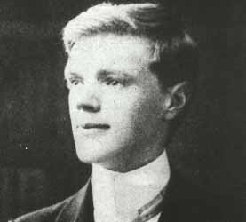
There’s no getting away from it, mankind falls forever into the two divisions of aristocrat and democratic. … We are speaking now not of political parties, but of the two sorts of human nature: those that feel themselves strong in their souls, and those that feel themselves weak. … So that religion, the Christian religion especially, became dual. The religion of the strong taught renunciation and love. And the religion of the weak taught down with the strong and the powerful, and let the poor be glorified. Since there are always more weak people than strong in the world, the second sort of Christianity has triumphed and will triumph. If the weak are not ruled, they will rule, and there’s the end of it. And the rule of the weak is Down with the strong.

They [the poor] had a will to destroy all power, and so usurp themselves the final, the ultimate power. This was not quite the teaching of Jesus, but it was inevitable implication of Jesus’ teaching, in the minds of the vast mass of the weak, the inferior. Jesus taught the escape and liberation into unselfish, brotherly love: a feeling that only the strong can know. And this, sure enough, at once brought the community of the weak into triumphant being; and the will of the community of Christians was anti-social, almost anti-human, revealing from the start a frenzied desire for the end of the world, the destruction of humanity altogether; and then, when this did not come a grim determination to destroy all mastery, all lordship, and all human splendor out of the world, leaving only the community of saints as the final negation of power, and the final power. … The community is inhuman, and less than human. It becomes at last the most dangerous because bloodless and insentient tyrant. For a long time, even a democracy like the American or the Swiss will answer to the call of a hero, who is somewhat of a true aristocrat: like Lincoln: so strong is the aristocratic instinct in man. But the willingness to give the response to the heroic, the true aristocratic call, gets weaker and weaker in every democracy as time goes on. All history proves it. Then men turn against the heroic appeal, with a sort of venom. The will only listen to the call of mediocrity: which is evil. Hence the success of painfully inferior and even base politicians. Brave people add up to an aristocracy. The democracy of thou-shalt-not is bound to be a collection of weak men. And then the sacred ‘will of the people’ becomes blinder, baser, colder and more dangerous than the will of any tyrant. When the will of the people becomes the sum of the weakness of a multitude of weak men, it is time to make a break.

Many men are socialists out of perverted power lust. And this form of lust is diabolical, deadly, it is a fearsome form of hate. Even Lenin was pure hate. The rest of the bolshvists are usually impure hate. It comes from the perversion of the nature of power in a man. … Lenin was a pure a poet of action as Shelley was of words. … He was, in a sense, the god of common people of Russia, and they are quite right, in the modern sense, to worship him. ‘Give us this day our daily bread’. And Lenin wanted above all things to give them their daily bread. And he could not even do that. What was love in theory became hate in practice.

D.H. Lawrence’s critical view on the inner workings of modern democracies explains very well the popularity of these red classics initially produced out of political expediency to address the specific situations and problems from which they emerge. In these works, our ritualistic mind recognizes archetypal situations quite familiar and akin to the human psyche. The dynamics we find elaborated in these works underscores our ambivalence toward democratic cultures and institutions, whether communist or capitalist, in which we desire and compete for the same things, sometimes even resorting to collective violence. What is contained in these red classics is none other than our democratic and aristocratic instincts that make us spiritual beings.

George Sorel, Reflections on Violence, trans. T. Hulme and J. Roth, Collier, 1961. quoted in Political Myth, by Christopher G. Flood. Routledge, 2002. pp.48-9. Flood quotes Sorel to show that he “considers that myth has a functional but not a factual validity.”
Flood. Political Myth, p.33. In this book, the author defines myth as a comprehensive story of the world that provides both the purpose and meaning for a political group. “Myth is a form of explanation. Sets of relationships are depicted: relationships between gods and gods, gods and man, gods and nature (animals, plants, places, the seasons and the weather, night and day, episodic occurrences, such as volcanic eruptions), man and man, man and nature, nature and nature. This constitutes an explanation of what the world is and how it came to be so. … The vision of ‘not only a general but a total understanding’ of the universe, as Levi-Strauss puts it is thus one vital aspect of myth. Another is the implication that what is to be known is known and has been known from the beginning. In Lauri Honko’s words, ‘the mythical view of the world is experienced as something static.’ … Myth can disclose the meaning of a group’s spatial and temporal sense of itself.”
Rene Girard, The Scapegoat. The Johns Hopkins University Press, 1986. p.42. “In order for all the persecutors to be inspired by the same faith in the evil power of their victim, the latter must successfully polarize all the suspicions, tensions, and reprisals that poisoned those relationships. The community must effectively be emptied of its poisons. It must feel liberated and reconciled within itself. This is implied in the conclusion of most myths. We see actual return to the order that was compromised by the crisis, or even more often the birth of a completely new order in the religious union of a community brought to life by its experience.”
Richard J. Golsan, Rene Girard and Myth. p.86.
Richard J. Golsan, Rene Girard and Myth. Routeledge, 2002. p.67.
He Jingzhi (Ho Ching-chih). “How the White Haired Girl was written and produced” in White Haired Girl. p.viii; “旧社会把人变成鬼，新社会把鬼变成人.”
Alan Lawrance, China under Communism, pp.8-11. “In May 1946 the Communists introduced in the ‘liberal areas’ a more radical policy intended to transfer land ownership to the poorer peasants. This was designed to confirm the loyalty of the majority of the villagers to the Communists in the impending civil war. The 1947 Land Law abolished landowner rights and authorized village associations to redistribute the land. The goal of ‘land to the tiller’ was being realized in accordance with the Communists’ views of a hierarchy of peasant classes. The poor and middle class peasants were to benefit but how precisely were the lines to be drawn and policies implemented? The problems raised led to the Directive on Land Reform and Party Rectification Work in February 1948. This February directive recognized that the attack on the middle peasants had gone too far. In 1948 the Central Committee accepted that middle peasants could make up 25% of their income by ‘exploitation’ e.g. from hiring seasonal hands, rent and interest. By 1949 it would be unsafe to characterize the process of liberation as a victory of the exploited classes. Far more pragmatically than Marxist theory might imply, the Communists won allegiance by leading the attack on the obvious grievances such as corruption, rack rents and hypertaxation. Most importantly their record contrasted with the Nationalists’ failure to implement reforms. … Land reform in a relatively moderate form was to be extended across the whole country. The intention was to eliminate the landlords as a class and to redistribute land without destroying the middle peasants. … In the period 1947-52, land reform spreading across China during and after the civil war is calculated to have taken 40% of China’s arable land from 4% of the people and redistributed it to 300 million peasants. … Landlords were also targets of the movement to suppress counter-revolutionaries which gained momentum from October 1950 when China entered the Korean War. The number of landlords executed has been variously estimated from 800,000 (government figures) upward to about 2 millions. Many who were not killed were sent to labor camps but the majority of those who had their land distributed remained in the villages as cultivators. Nevertheless, they had lost their political and social standing. It is noteworthy that one effect of land reform, particularly in south China, was that it undermined lineage as a social force, thus removing an alternative focus of loyalty to the regime.
Richard J. Golsan, Rene Girard and Myth. Routeledge, 2002. p.85. In Chapter Six, The Bible: Antidote to Violence, the author states, the author says, “Rene Girard’s interpretation of the Bible and the crucial role he assigns it in the history of Western culture are doubtless the most controversial features of his entire intellectual enterprise. In Things Hidden Since the Foundation of the World Girard argues that our ability to break down and analyze ‘cultural mechanisms’ such as scapegoating and demystify the role of sacrificial violence in the establishment or reestablishment of order is attributable to the ‘formidably constraining influence’ of biblical texts. The Bible, in short, offers us real knowledge of human relations. …What is the essence of Biblical revelation? It centers on a change—or, more precisely, a reversal—of perspective. The violent origins of culture, and especially acts of foundational, sacrificial violence, are viewed from the standpoint of the victim rather than of the persecutor. …A convenient starting point for measuring the impact of the biblical revolution can be found in what Girard labeled ‘texts of persecution.’ In the Judeo-Christian world, according to Girard, myths die out and are replaced by texts of persecution. Moreover, these texts represent an intermediary phase between myths and a more recent stage in which ‘radical demythification’ is possible. They are accounts of collective violence which partly, but only partly, expose the persecution as arbitrary.”
Ibid. Girard, The Scapegoat. “Culture is somehow eclipsed as it becomes less differentiated. Once this is understood, it is easier to understand the coherence of the process of persecution and the sort of logic that links all the stereotypes of which it is composed. Men feel powerless when confronted with the eclipse of culture; they are disconcerted by the immensity of the disaster but never look into the natural causes; the concept that they might affect those causes by learning more about them remains embryonic. Since cultural eclipse is above all a social crisis, there is a strong tendency to explain it by social and, especially, moral causes. After allhuman relations disintegrate in the process and the subjects of those relations cannot be utterly innocent of this phenomenon. But rather than blame themselves, people inevitably either society as a whole, which costs them nothing, or other people who seem particularly harmful for easily identifiable reasons.” p.14.
Rene Girard. Violence and the Sacred. 1977, Johns Hopkins UP; p.115.
William Hinton. Fanshen: A Documentary of Revolution in a Chinese Village, Vintage, 1966. pp.7-8. In these pages, Hinton quotes extensively the Draft Agrarian Law formulated and announced to the world on December 28, 1947 by the CCP.
Hinton, Fanshen:.p.8. “This new Draft Agrarian Law was destined to play as important a role in China’s Civil War of 1956-50 as the Emancipation Proclamation played in the American Civil War of 1861-65. Lincoln’s Emancipation Proclamation confiscated without compensation $3 billion worth of property in slaves; put an end to the possibility of a compromise between the industrial North and the slave-holding South in the military contest then raging; made the slave system itself, rather than regional autonomy, the nub of the conflict; declared the way for the recruitment of hundreds of thousands of emancipated black men into the Union Army; and spread the war into every corner of Confederate territory with devastating effect. Mao’s Draft Agrarian Law confiscated without compensation $20 billion worth of property in land; put an end to all possible compromise between the Communist Party and the Guomingdang; made countrywide overthrow of the landlords and compradors.” The success of the communist movement, which led to the consolidation of political powers and to the founding of the People’s Republic in 1949 does resemble the American Civil War in many respects with the following exception. What Lincoln abolished through the Civil War was an economic system that enslaved people and treated human beings as properties, whereas what Mao accomplished through communist land reform was the abolition of property rights of some people and a redistribution of property according to an egalitarian utopia. The two civil wars may be equal in magnitude and importance, or even comparable in the level of violence, but they differ significantly in meaning and social outcome as history offers us greater and greater critical distance from which to reflect upon these events, especially now when the CCP has reversed its policies regarding private property and ownership rights. But, what is of great importance here is how fictional representations and the political discourse of the communist revolution act in unison as if possessed by a raging monster.
Ibid. Hinton, Fanshen: p.vii. At the request of Zhou Enlai, China’s premier, the book was translated into Chinese in 1980.
Hinton, Fanshen: p.73. “When the Japanese army drove into the rural districts of the hinterland, the most conspicuous men in every community were, of course, the leading gentry who headed the village administrations and ran the economic, social, and religious institutions. The Japanese took it for granted that these people would not resist, and for the most part they were not disappointed. After all, the leading gentry had the most property to lose in any annihilation campaign. They dared not mobilize and arm the peasantry for fear that these armies would someday turn against them. When the chips were down, when they were forced to choose between collaboration and resistance, they often found that they had more in common with the invader than they had with their own tenants. At least the Japanese officers shared their own respect for private property, the sanctity of land rents, and the importance of orthodox religious worship”
White Haired Girl, trans. by Yang Hsienyi and Gladys Yang. Foreign Languages Press, 1954. p.9.
Rene Girard, The Scapegoat. p.19.
Rene Girard, The Scapegoat. p.25.
Rene Girard, The Scapegoat. p.29.
Rene Girard, The Scapegoat. p.27.
Hinton, Fanshen:.p.27, 37, and 38. “But in the quiet countryside landlords continued to don long gowns, collect exorbitant rents, pay off the soldiery, manicure their finger-nails, and eat white flour made from wheat. Tenants continued to wear dirt-stained trousers, sweat in the fields, render up the major part of what they raised in taxes and rent, and shiver through the winter on coarse millet, chaff, and bran. … a typical community was made up of a small number of landlords and rich peasants and a large number of hired laborers, poor peasants and middle peasants. The landlords and rich peasants, who made up less than 10 percent of the rural population owned from 70 to 80 percent of the land, most of the draft animals and the bulk of the carts and implements. The hired laborers, the poor peasants, and the middle peasants, who made up more than 90 percent of the population, held less than 30 percent of the land, only a few draft animals, and a scattering of implements and carts—a condition which placed them perennially at the mercy of the more well-to-do and condemned them to a life of veritable serfdom. … They (landlords) did not live in palaces. They enjoyed none of the conveniences of modern life. In most cases, the only difference between their homes and the rest of the population was in the construction materials used. The prosperous built with brick, the poor with abode. Both materials came from the earth underfoot and the interior plan and conveniences of a brick home differed little from those of a house built of abode. … This world of security, relative comfort, influence, position, and leisure was maintained amidst a sea of the most dismal and frightening poverty and hunger—a poverty and hunger which at all times threatened to engulf any family which relaxed its vigilance, took pity on its poor neighbors, failed to extract the last copper of rent and interest, or ceased for an instant the incessant accumulation of grain and money. Those who did not go up went down, and those who went down often went to their deaths or at least to the dissolution and dispersal of their families.
Flood. Political Myth, p.275.
Hinton, Fanshen: p.55. “As a sympathetic observer of the land reform, Hinton easily identifies the weaknesses in the communist movement, “As victims of village idiocy the peasants had little opportunity to learn of large-scale production and the potential abundance that it offered mankind. Their idea of the good society was one in which everyone had a plot of land, a roof overhead, clothes to wear and wheat dumplings to eat. The egalitarianism they dreamed of was noble, but it was also utopian—there being no conceivable way in which every family could enjoy a prosperous life on a long-term basis as long as production was atomized by small private holdings and cursed with primitive technique. Even if all the means of production could be equally divided, what was to prevent the old process of differentiation which had originally produced landlord and tenant from producing them all over again?”
For example, Flood says the following: “The ideological novel is oriented toward persuading its readers by its force of demonstration. It exhibits an unambiguous, dualistic system of values linked to an ideology which exists outside the novel itself. … Thus, at the crude extreme, if a positively valorized character, possessing a range of physical, moral, intellectual, and other traits which mutually reinforce one another in representing the character as admirable, says or does the same ideologically marked things at times, and other positively valorized characters, together or separately, say/do similar things at times, whereas negatively valorized characters say or do the opposite, then the reader may well assume an invitation to interpret the story in a particular way, even in the absence of commentaries by an omniscient narrator to spell out the meaning of the story.” Pp.130-131. Christopher G. Flood. Political Myth.
Christopher G. Flood. Political Myth, Routeledge, 2002. p.275. In his conclusion, the author states, “The aim of this book has been to demythologize the theory of political myth by showing that mythmaking is an everyday practice which permeates the discourse of political communicators. There is no need to consider myths a variant expressions of psychological archetypes. There is no need to posit a special form of consciousness or to situate the process of mythmaking within a psychopathology of the irrational. There is nothing strange about mythmaking. There is nothing wrong with it. It is an entirely normal way of making political events intelligible in the light of ideological beliefs. Some stories acquire importance within a social group over a long period of time. Others have only the most ephemeral currency. But the production and reproduction of mythopoeic narratives are constant features of political life.”
Adolphe Jensen. Quoted in Violence and the Sacred, by Rene Girard. p.91.
Ibid. Girard. Violence and the Sacred. p. 14.
1964年10月8日，毛泽东主席在观看《红色娘子军》之后留下了著名的三句话：“革命是成功的，艺术是好的，方向是对的。”这部根植于真实革命斗争故事的舞剧不仅给人以独特的历史回忆，更让中国观众在民族文化和西方经典的融合中，体会到高雅艺术的巨大感染力。
Rene Girard. Deceit, Desire and the Novel: Self and Other in Literary Structure. Johns Hopkins University Press, 1961. The author attempts to define the essence of a certain type of novel which he calls the novel of mediated desire by analyzing five major novelists: Cervantes, Stendhal, Flaubert, Proust, and Dostoevsky. Girard’s analysis of mimetic desire offers insights into the character Ah Q who, among other things, exemplifies what he calls triangular desire, or “the victim of metaphysical desire imitates the desires of others in the hope that realizing that desire will bring self-fulfillment and will allow the victim to partake of the divinity of the other. Since the divinity of this other, this mediator, is illusory, all such imitations can only result in failure and disappointment. Over time, the victim of metaphysical desire comes to understand this fact, but he is unwilling to give up his quest, his imitation of others, since to do so would be to renounce salvation.” p.25. Rene Girard and Myth, by Richard J. Golson; Routledge, 2002.
Richard J. Golson sums up Rene Girard’s theory of myth in the following way, “As horrible as these reprisals against innocent victims are, they also point to a way out of the dilemma created by human violence. If one surrogate or group of surrogate victims can become the focus of all the hostilities of the larger group, then that one victim or group of victims will deflect or channel internal dissensions outside the group. Once this occurs, social harmony is reestablished and the development of culture becomes possible. In order to understand how this collective subordination takes place, it is necessary to look more closely at the violent crisis within the group. In Violence and the Sacred Girard labels this crisis the ‘sacrificial crisis’ because it can be resolved only by means of the sacrifice or expulsion of a surrogate victim, or scapegoat.” p.31. Rene Girard and Myth, Routledge, 2002.
Ibid. Rene Girard. Things Hidden since The Foundation of the World. p.288. In this chapter entitled “Mimetic Desire,” the author points out, “Desire is mimetic crisis itself; it is the acute mimetic rivalry with the other that occurs in all circumstances we call ‘private’, raging from eroticism to professional or intellectual ambition. …Desire may not be a specifically modern invention, but it is in modern life that desire has blossomed; or, more exactly, it is as a modern phenomenon that desire has blossomed.” Girard goes on to talk about how mimetic desire is always for things immaterial, which as a theory is perfectly applicable to the communist culture which, although built upon historical materialism, forbids and discourages the acquisition of material wealth on the part of the individual. “The object of desire is indeed forbidden. But it is not the ‘law’ that forbids it, as Freud believes—it is the person who designates the object to us as desirable by desiring it himself. The non-legal prohibition brought about through rivalry has the greatest capacity to wound and traumatize. … Once he has entered upon this vicious circle, the subject rapidly begins to credit himself with a radical inadequacy that the model has brought to light, which justifies the model’s attitude toward him. The model, being closely identified with the object he jealously keeps for himself, possesses—so it would seem—a self-sufficiency and omniscience that the subject can only dream of acquiring. The object is now more desired than ever. Since the model obstinately bars access to it, the possession of this object must make all the difference between the self-sufficiency of the model and the imitator’s lack of sufficiency, the model’s fullness of being and the imitator’s nothingness.”
D.H. Lawrence. Apocalypse. Granada, 1981. p.9.
Ibid. Lawrence. Apocalypse. Pp. 8, 17, 129-130.

